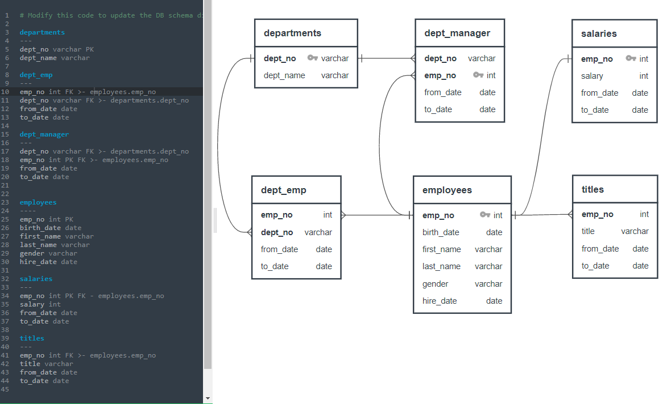

1. **List** the following details of each employee: employee number, last name,

 first name, gender, and salary.

select employees.emp_no, employees.last_name, employees.first_name, employees.gender, salaries.salary

from employees

inner join salaries on salaries.emp_no = employees.emp_no

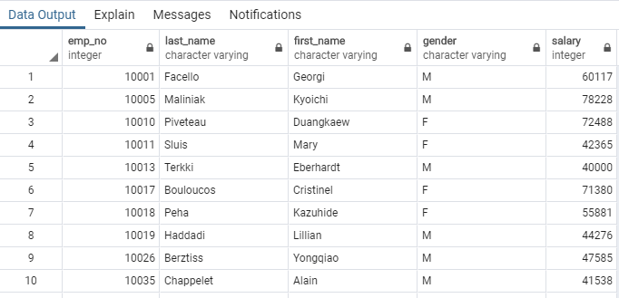

2. **List** employees who were hired in 1986.

select count(employees.emp_no) from employees

where employees.hire_date >= '01/01/1986' and employees.hire_date <= '12-31-1986'

Count of all employees hired during 1986

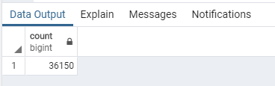

select employees.emp_no, employees.last_name, employees.first_name, employees.hire_date

from employees

where employees.hire_date >= '01/01/1986' and employees.hire_date <= '12-31-1986'

order by employees.hire_date desc

**Descending by Hire Date**

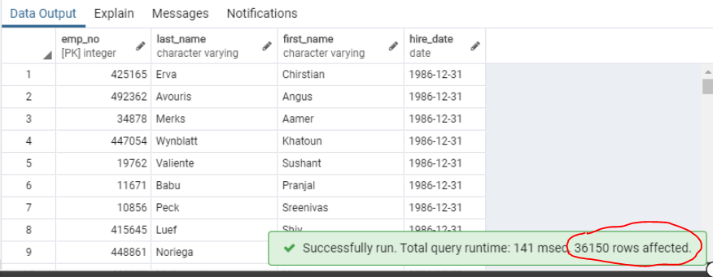

**Ascending by Hire Date**

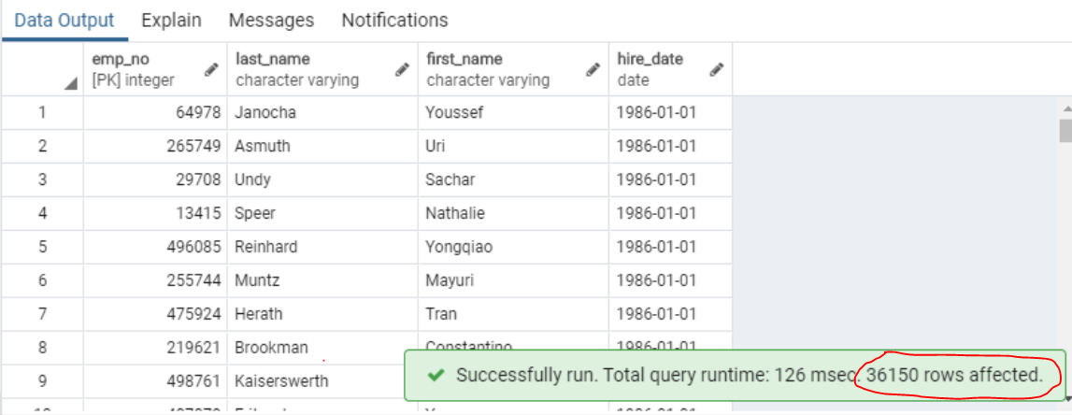

3. **List** the manager of each department with the following information: department

number, department name, the manager's employee number, last name, first name, and

start and end employment dates.

Note: Margareta Markovitch was hired on 1/1/1985 but since there is no Termination date I used the last date of her performing as a manager as the employment end-date (10/1/1991).

Select  dept_manager.dept_no as "Dept_Number",

        dept_manager.to_date as "Dept_Mgr_Last_Date",

        dept_manager.emp_no as "Dept_Mgr_Employee_Number",

        employees.last_name as "Dept_Mgr_Last_Name",

        employees.first_name as "Dept_Mgr_First_Name",

        employees.hire_date as "Dept_Mgr_Hire_Date",

        departments.dept_name as "Dept_Name"

from dept_manager

inner join employees on employees.emp_no = dept_manager.emp_no

inner join departments on departments.dept_no = dept_manager.dept_no

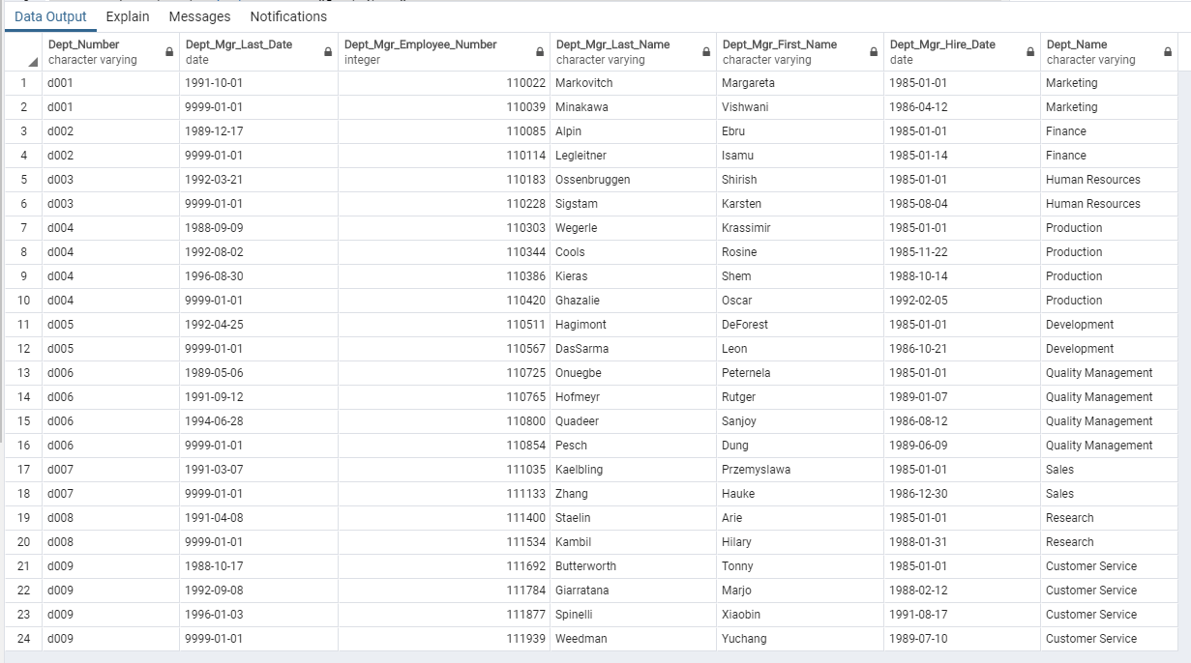

4. **List** the department of each employee with the following information:

employee number, last name, first name, and department name.

**I discovered that I had not created a necessary foreign key to answer this question. Thus I added a foreign key relationship between table "dept_emp" and table "employees" after I had imported the CSV data. I later went back and updated the ERD shown at the top of this document.**

Alter Table dept_emp

Add constraint add_FK_for_emp_no

Foreign Key (emp_no)

References employees (emp_no)

Select  employees.emp_no as "Employee_Number",

        employees.last_name as "Employee_Last_Name",

        employees.first_name as "Employee_First_Name",

        departments.dept_name as "Dept_Name"

from employees

inner join dept_emp on dept_emp.emp_no = employees.emp_no

inner join departments on departments.dept_no = dept_emp.dept_no

Order by departments.dept_name, employees.last_name

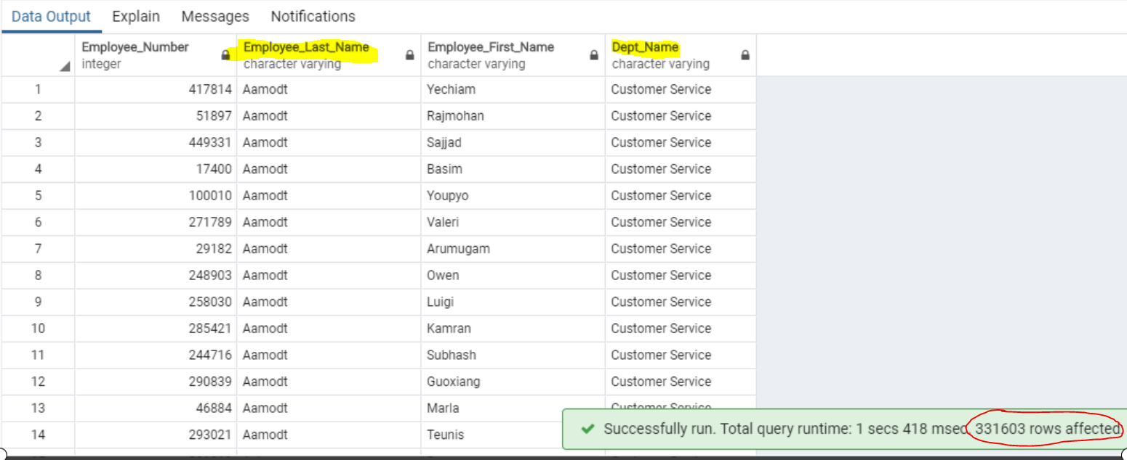

5. **List** all employees whose first name is "Hercules" and last names begin with "B."

Select  employees.emp_no as "Employee_Number",

        employees.last_name as "Employee_Last_Name",

        employees.first_name as "Employee_First_Name"

from employees

where employees.last_name like 'B%' and employees.first_name = 'Hercules'

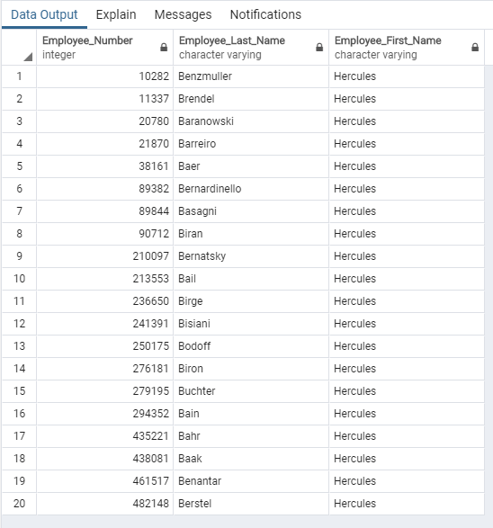

6. **List** all employees in the Sales department, including their employee number, last

name, first name, and department name.

Select  employees.emp_no as "Employee_Number",

        employees.last_name as "Employee_Last_Name",

        employees.first_name as "Employee_First_Name",

        departments.dept_name as "Dept_Name"

from employees

inner join dept_emp on dept_emp.emp_no = employees.emp_no

inner join departments on departments.dept_no = dept_emp.dept_no

where departments.dept_name = 'Sales'

Order by departments.dept_name

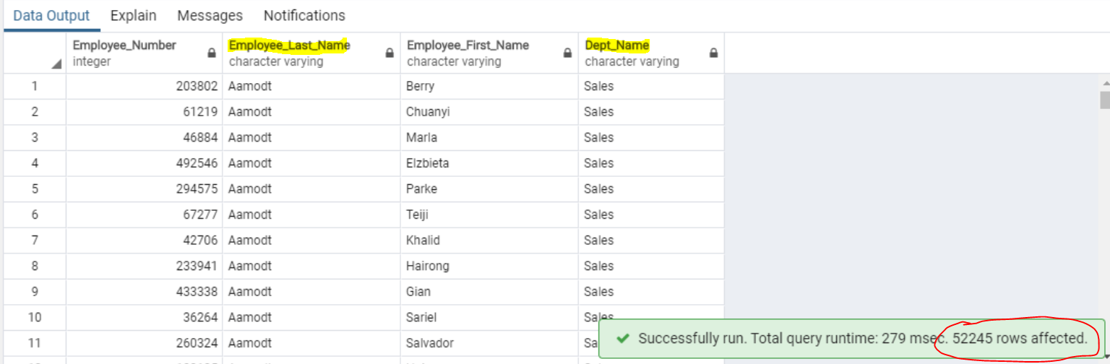

7. **List** all employees in the Sales and Development departments, including their

employee number, last name, first name, and department name.

Select  employees.emp_no as "Employee_Number",

        employees.last_name as "Employee_Last_Name",

        employees.first_name as "Employee_First_Name",

        departments.dept_name as "Dept_Name"

from employees

inner join dept_emp on dept_emp.emp_no = employees.emp_no

inner join departments on departments.dept_no = dept_emp.dept_no

where departments.dept_name = 'Sales' or departments.dept_name = 'Development'

Order by employees.emp_no

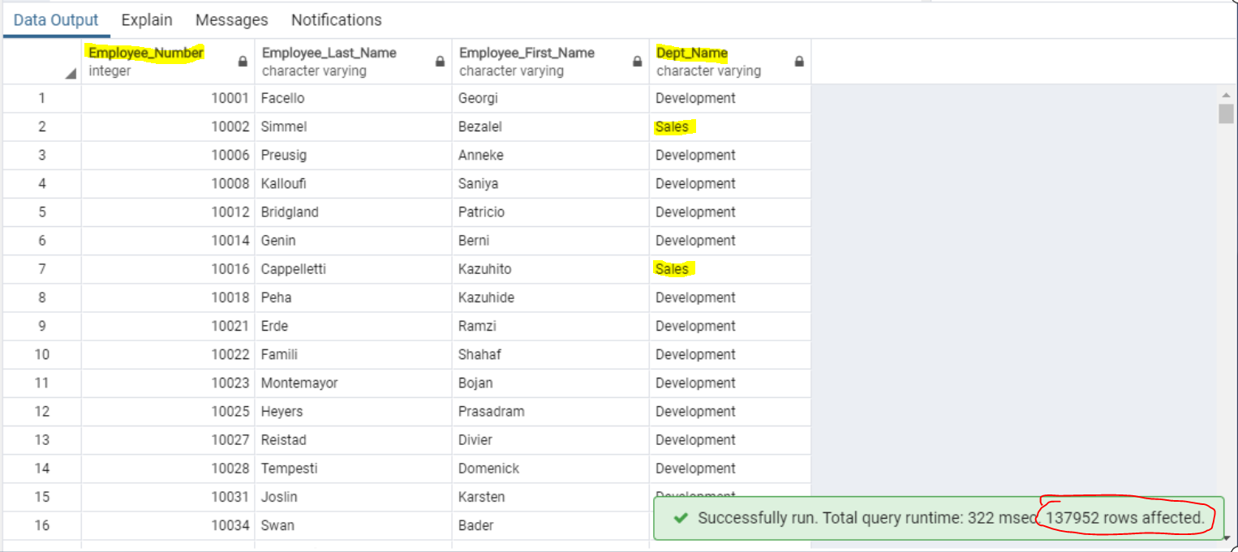

8. **In descending order, list** the frequency count of employee last names, i.e., how

many employees share each last name.

Select  employees.last_name, (count(employees.last_name)) as name_count

from employees

Group by employees.last_name

order by name_count desc **--- sort in descending order by name_count**

Select  employees.last_name, (count(employees.last_name)) as name_count

from employees

Group by employees.last_name

order by employees.last_name desc **--- sort in descending order by last_name**

|  |  |
| --- | --- |
|  |  |